Order Of Service

Singing: Psalm 146—CW page 120

Reading: Psalm 102:18-28

Opening Hymn: TLH 41

Reading: Acts 20:7-12

Request Hymn: CW Supplement 735

Reading: Matthew 8:1-4

Sermon Hymn: TLH 396

Sermon Text: Mark 7:24-30

Dogs Eat The Crumbs

Prayer

The Apostles’ Creed, TLH page 12

Holy Communion

The Lord's Prayer

The Blessing

Closing Hymn: TLH 48

* * * * * * * * * * *

Bible Study: Lambs: Golden Plover
Sheep: Proverbs 18:16-20


Spring—Gooseberry Falls, MN

Water
Of
Life

23 June 2019

W A T E R O F L I F E

Independent Christian Church—Conservative Lutheran Doctrine

Worship Service: 9:30 a.m. Bible Study: 10:45 a.m.

Larry Cooper, Pastor E-Mail address:
111 N. Ridge Road lcooper@wateroflife.cc
Coon Valley, WI 54623 Web Site:
www.wateroflife.cc

* * * * * * * * * * * * * * * * * * * * * * * * * * *

Sermon Text: Mark 7:24-30

Dogs Eat The Crumbs

* * * * * * * * * * * * * * * * * * * * * * * * * * *

Mark 7:24 And from thence he arose, and went into the borders of Tyre and Sidon, and entered into an house, and would have no man know it: but he could not be hid.
:25 For a certain woman, whose young daughter had an unclean spirit, heard of him, and came and fell at his feet:
:26 The woman was a Greek, a Syrophenician by nation; and she besought him that he would cast forth the devil out of her daughter.
:27 But Jesus said unto her, Let the children first be filled: for it is not meet to take the children's bread, and to cast it unto the dogs.
:28 And she answered and said unto him, Yes, Lord: yet the dogs under the table eat of the children's crumbs.
:29 And he said unto her, For this saying go thy way; the devil is gone out of thy daughter.
:30 And when she was come to her house, she found the devil gone out, and her daughter laid upon the bed.

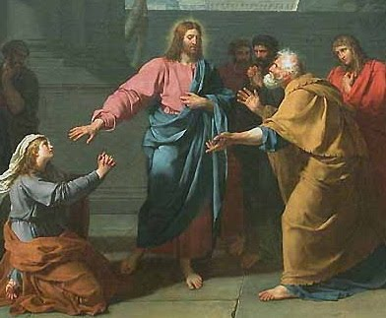

O woman, great is thy faith!

Matthew 15:28

